PROJECTREPORT

Title of Project:
#Include Official Website
A Digital Platform for Club Management and Engagement.
It will provide an interactive and user-friendly platform for students to access information about events, mentors, members, and club updates.

Group Name:
Khushi Soni
Komal Jatiya

Guide and Co-Guide Name:
Guide: Dr. Upendra Singh
Co-Guide: Shraddha Verma

Field of Title
Technical Club Management and Digital Engagement
In today’s digital world, student clubs play an essential role in fostering learning, collaboration, and technical skills. #Include is a technical club that provides students with a platform to grow and showcase their talents. To improve communication and accessibility, the club is developing an official website that serves as a centralized hub for all activities.
Background of the Project :
#Include is the official club of the Information Technology department, created to help students enhance their technical skills and stay updated with the latest coding technologies. The club provides a platform for students to learn, collaborate, and grow in the field of programming, software development, and emerging technologies.
The club regularly organizes hackathons, coding competitions, workshops, and mentorship programs to help students improve their problem-solving abilities and technical knowledge. However, without a dedicated website, it becomes difficult to manage events, share updates, and maintain proper records of club activities.
To solve this problem, the #Include Official Website is being developed. It will serve as a one-stop platform where students can:
Get real-time updates on upcoming and past events.
Learn about mentors who guide the club.
Find details about club members, including seniors and juniors.
Access an online newsletter, replacing traditional department board notices.

Existing Solutions in the Market:
Many clubs use social media, free website builders, or notice boards to share updates, but they have limitations:

Social Media (Facebook, LinkedIn, WhatsApp) – Good for updates but lacks proper organization.

Google Sites & Free Website Builders – Static and require manual updates.

University Notice Boards & Emails – Not accessible to everyone at all times.

Why a Better Solution?
These methods are scattered and hard to manage. The #Include Official Website will provide a centralized, interactive, and easy-to-use platform for all club activities.

Summary of the Project
The #Include Official Website is designed to serve as a central platform for the Information Technology club. It aims to provide students with easy access to club activities, event details, and important announcements in a well-organized manner.
Key Features of the Website:

Event Management:

Displays both upcoming and past events with details.
Allows students to stay updated on hackathons, coding competitions, and workshops.
Mentors Page:
Showcases faculty mentors who guide and support the club.

Club Members Directory:
Lists current senior and junior members of the club.

Online Newsletter:
Provides a digital version of the department’s notice board.
Helps students stay informed about club updates and activities.

Technology Used Detailed Description:

Frontend: Built using HTML, CSS, JavaScript, and Bootstrap for a modern and responsive UI.

Backend: Developed using Node.js ensuring smooth server-side operations.
Database: Uses /MongoDB to store event details, member information, and newsletter subscriptions.

APIs Implemented:
POST /add-event – Admins can add new events.
GET /events – Displays past and upcoming events.
POST /subscribe-newsletter – Users can subscribe to the newsletter.
GET /mentors – Shows faculty mentors.
GET /members – Lists all active club members (seniors and juniors).

Working Principle:

- Event Management: Admins add events with details and registration links.
- Mentor Section: Displays faculty advisors and their contributions.
- Club Members Directory: Lists all active members with categories.
- Newsletter Subscription: Users can receive updates via email.
- User Interaction: Visitors can access information, register for events, and explore the club's activities.

Objective:
The key objectives of this project include:

- Provide a centralized platform for #Include club activities.
- Ensure easy access to event details, mentor information, and newsletters.
- Improve transparency and engagement among students.
- Create a responsive and visually appealing website.
- Implement secure and structured data management.

Diagrams of the project:

- Activity diagram

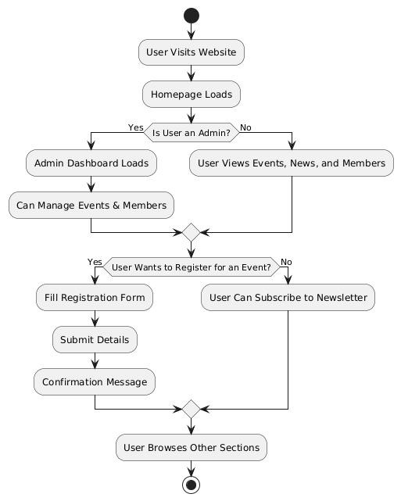

- Architecture diagram
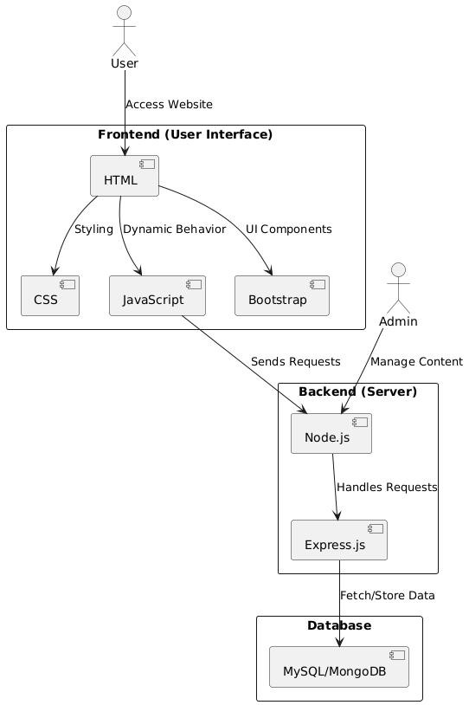

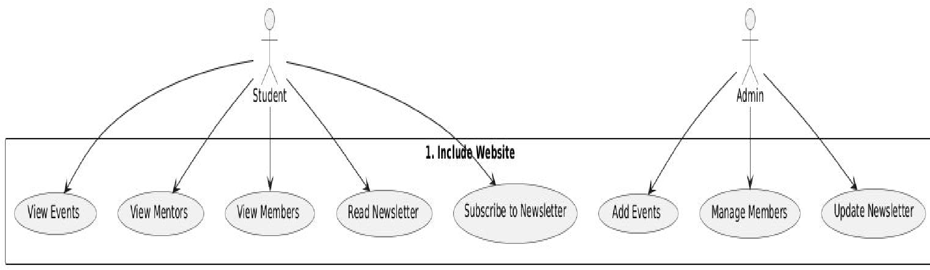
- Use case diagram

4 .Class diagram

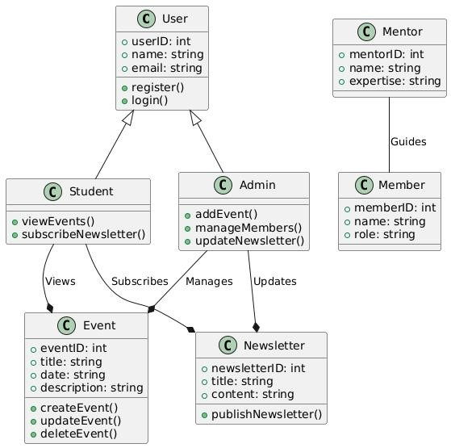

- Sequence diagram

